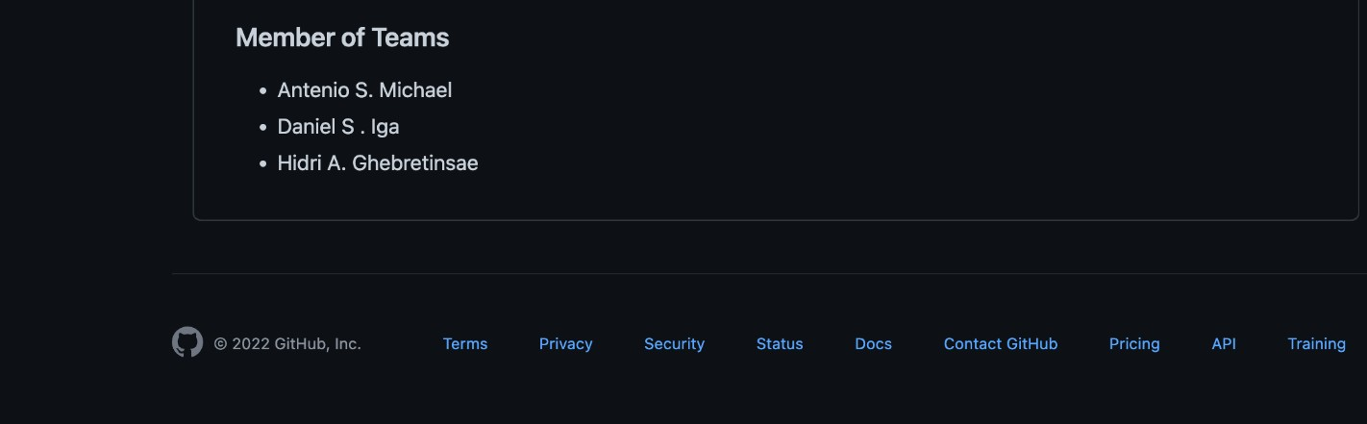

**Problem Description:**

**BlueCollar Application**

The BlueCollar Application is a platform which helps the BlueCollar workers meet their clients at a minimum cost which reduces the cost of advertising and help drive business for the blue collar workers. The application at the same time makes it easy for the customers/clients to contact the service providers at the snap of a finger in the comfort of their homes or offices

BlueCollar Application is an app where blue collar workers such as Plumbers, Electricians, Welders, Painters, Carpenters, Gardeners, Masons, Stylists, Janitors can register themselves, get their credentials verified by an Administrator who is normally an Employee of BlueCollar Company and then get listed onto the platform for potential clients to hire them. Users(clients) who need the services such as plumbing, electrical installation, welding, painting log into the application and get to choose the preferred worker according to their preference.

For our clients we offer door to door services, the services we offer are legitimate because our workers must go through verification before publishing them to our site. Your safety is guaranteed for security comes first for us. Our rates are Affordable.

If it's been hard for you to find a job, then you are at the right place. Before we publish you to the site we have to first audit and verify your credentials and get to know your work experience before proceeding to list you on the BlueCollarApp website. A user can post any job need to fix for his properties. The essence of the platform is to bring the blue-collar workers/companies under one platform to serve on the resources and time wasted looking around for their services.

**How the BlueCollar worker uses the app**

* The Blue Collar worker/company can create an account with the app to advertise their services
* The BlueCollar worker can log into their account and update their company information such as the prices, discounts, services.
* The BlueCollar worker can log in and check on the notice board for the clients that are in need of a particular service.
* The BlueCollar worker can then proceed to contact the client using the app.

**How the Client/Customer uses the App**

* The client can create an account with the app to advertise their services
* The client can log in and check on the notice board for the clients that are in need of a particular service.
* The client worker can then proceed to contact the client using the app.
* The client can browse for any services such as plumbing, electrical works, painting upon logging into the app
* The client can as well post a job on the platform and they can be contacted by the service provider/blueCollar worker/company.
* The customer can select/contact the service-provider of their choice they want by location or job-category.
* The client can browse the list of service providers either by location or job-category
* The client/customer can give feedback about the services of the blue company worker.
* The client can give feedback about a blueCollar company.

**How the System Administrator uses the App**

* The company admin verifies the information of the blueCollar company/worker and then add them onto the platform.
* The admin can remove a company/blue collar worker from the platform

